(Journal of Atmospheric and Solar-Terrestrial Physics, doi: 10.1016/j.jastp.2004.07.023, in press)

Solar activity signatures in mesopause region temperatures and atomic oxygen related airglow brightness at El Leoncito, Argentina
J. Scheer*, E. R. Reisin, and C. H. Mandrini
Instituto de Astronomía y Física del Espacio, CONICET-UBA, Buenos Aires, Argentina
* Corresponding author. Fax: +54-11-4786-8114.
IAFE, Ciudad Universitaria, CC 67 - Suc. 28, 1428 Buenos Aires, Argentina
E-mail address: jurgen@caerce.edu.ar
Abstract
Rotational temperatures and airglow brightness variations of the OH(6-2) and O₂(0-1) bands measured at El Leoncito (32°S, 69°W) from 1998 to 2002 are analyzed to detect solar activity signatures. The emissions correspond to nominal altitudes of 87 and 95 km, respectively. The homogeneous and consistent data set covers the rise, the two distinct maxima, and the start of the decline of the present solar activity cycle. The modulation of solar activity around the Gnevyshev gap (particularly pronounced in this cycle) has been so strong as to motivate the expectation to detect its signature in such a relatively short data set. While at 87 km, we practically observe no correlation with solar radio flux, or at most a weak correlation in temperature, we find a moderate positive temperature and airglow brightness effect at 95 km. This is a remarkable difference, in view of the small separation between the two altitude levels. The quantitative results lie close to the lower limits of our previous estimates in a recent trend analysis. However, the behaviour at 95 km changes abruptly between anticorrelation, correlation, and no correlation. From December 1998 to July 2001 the correlation was very strong. From the standpoint of atmospheric nonlinear dynamics, variations in the degree of correlation in different years and at different observing sites should not be surprising.
Keywords: Airglow, Mesopause Region, Southern, Temperature, Solar Activity, Trends

1. Introduction
Atomic oxygen plays an important role in the energy balance of the upper atmosphere. It is produced in the thermosphere by photodissociation of molecular oxygen, through absorption of solar UV in the Schumann-Runge bands and continuum, at about 140 - 200 nm wavelength. Of course, this strong absorption of solar UV causes a massive solar forcing of thermospheric temperature (reaching several hundred kelvins, or about 50 % of the average temperature). In the mesopause region (80 - 100 km), atomic oxygen is supplied by downward transport, and the solar cycle effect is expected to be considerably smaller. For example, in the MSISE-90 model (Hedin, 1991) that reflects existing knowledge of the upper atmosphere, the effect is exactly zero at 90 km, and also at 100 km altitude.
Many observational data of good quality are needed to determine the response of the mesopause region to solar activity variations more precisely. Temperatures can be conveniently derived from airglow emissions in the OH bands originating at 87 km, and the O₂ Atmospheric band at 95 km. At the altitude of the OH emission, even recent reports of solar cycle effects on temperature have been contradictory (see, for instance the review of temperature trends by Beig et al., 2003).
With respect to OH airglow brightness, which is approximately proportional to atomic oxygen concentration, Wiens and Weill (1973) observed a 25 % increase over one solar cycle. The authors qualified this at that time as "not especially large", although it is twice as much as what would be expected from the MSISE-90 model.
About solar cycle effects on airglow brightness and temperature at the emission height of the O₂ band, only few results have been reported until now. At these altitudes, Hernandez (1976) derived a very strong anticorrelation with solar activity from Doppler temperature measurements of the atomic oxygen green line observed over one solar cycle. Using the same technique, Nikolashkin et al. (2001) recently arrived at a similar conclusion. A solar cycle effect about as strong, but with opposite sign has been reported from lidar observations by She et al. (2002) for 98.5 km. This again shows that observations cannot be generalized. At any rate, they refer to different geographical locations and solar cycles.
When long time series of lidar temperature profiles or of airglow brightness and rotational temperature data from both airglow bands for the same location become available, they will supply valuable information about solar cycle effects in the mesopause region, permitting comparisons between the different altitude levels. Before such data sets spanning preferably several solar cycles have been acquired, one has to deal with the limitations of existing observations.
The Argentine airglow data set obtained at El Leoncito (31.8°S, 69.2°W) has led to preliminary conclusions about solar cycle effects in the past. Results based on early data acquired in campaign style in 1984, 1986, 1987, 1990, and 1992 (presented at the 1993 IAGA conference in Buenos Aires) signalled the absence of a solar cycle signature in OH temperatures but a positive correlation in O₂ temperatures. These results have been updated and revised recently (Reisin and Scheer, 2002; hereafter shortly "RS2002"). The principal objective of that paper was the analysis of long-term trends, but upper limits for possible solar cycle effects on temperatures and airglow intensities were also estimated. The results confirmed qualitatively the earlier findings: absence of a solar cycle effect at 87 km, but a possible positive correlation, at 95 km.
Here, we will concentrate on the most recent set of data with uniform quality to derive more quantitative estimates of the solar cycle effect, at both emission altitudes. We take advantage of the fact that during the present solar cycle (number 23), a double peak is clearly defined.
That this double-peaked structure is a characteristic feature of the solar activity cycle has become more evident during the recent decades, with access to more reliable solar activity information pertaining to different levels in the solar atmosphere. In the early 1960s, M. N. Gnevyshev (1977) first claimed the existence of double-peak structure for the coronal activity maximum during the 19th solar cycle. Recent studies (see, e.g. Feminella and Storini, 1997; Mandrini et al., 2002) confirm these findings and show that structured activity maxima are detected in all solar atmospheric layers up to the interplanetary medium (Gonzalez et al., 1990). As the solar magnetic field is the main factor behind solar activity, the origin of the double-peaked cycle structure should be directly linked to the solar dynamo that generates this field. In general, solar dynamo models reproduce the observations (e.g. sunspot numbers) only qualitatively. However, double peaks can indeed be identified in the output of some dynamo models, and are caused either by stochastic forcing or by nonlinear effects (see, e.g. Charbonneau and Dikpati, 2000; Mininni et al., 2000, 2001).
The presence of these structured maxima makes an analysis of short data sets (in the order of half a solar cycle) possible, as long as the data cover the solar maximum (and data quality is high enough). Our airglow data obtained between April 1998 and October 2002 have such a temporal coverage.
2. Airglow data
Our analysis is based on nocturnal measurements of the OH(6-2) Meinel and the O₂b(0-1) Atmospheric bands. The measurements were done with the same tilting filter spectrometer described in detail by Scheer (1987; Scheer and Reisin, 2000, 2001). The statistically independent but dynamically related four parameters (temperatures and airglow intensities of both emissions) are simultaneously determined with a temporal resolution of about 80 s, while achieving a typical uncertainty of about 2 %. This corresponds to mean individual temperature errors of about 4 K. Therefore, already at the level of nocturnal means with hundreds of individual measurements these statistical errors are negligible.
Here, we present only the more recent data taken at El Leoncito between August 1997 and October 2002. During this time, the instrument operated with the same optical configuration, without any change of the interference filter, or any other modifications affecting sensitivity. Part of this data set (until mid-May 2001) is as described in RS2002. The new data (346 additional nights representing about 110,000 individual observations) add useful information because they extend the coverage over the second solar activity maximum.
Since only one filter is responsible for the data quality at both airglow emissions, it is not very difficult to keep instrument stability under control. On the one hand, photon counting mode assures stable long-term instrument sensitivity, as checked by comparing stellar backgrounds (as in Scheer and Reisin, 2000; for a more recent example, see http://www.iafe.uba.ar/aeronomia/stabilit.html). Additionally, the stability of spectral characteristics was verified a few times per year by recording neon spectra (see Scheer, 1987). Auroral contamination is not a problem for our data (RS2002).
The nocturnal data coverage is shown in Fig. 1, for one of the four observed parameters. Often, the number of data is limited only by the duration of the night. This leads to the seasonal modulation clearly visible in the figure. The mean number of data per night is 335, only about 15 % smaller than the maximum possible for complete nights.
The data from August 1997 to February 1998 were still mostly taken in attended mode. The establishment of fully automatic mode in April 1998 led to rather homogeneous coverage during the following years (except for an almost 2-month gap in 2001). The good monthly data coverage is partly due to the moonlight correction (Scheer and Reisin, 2001) that makes observation during full moon nights possible, and has led to nearly uninterrupted runs of data nights (with the longest one, in 2002, lasting for about 5 months).
The 1997 data are shown here only for completeness, but it is clear from their particular behaviour that they were subject to special aeronomical conditions, probably due to the strong 1997 ENSO event (Scheer and Reisin, 2000; see also RS2002). Therefore, they do not enter the present solar activity analysis, but will serve to illustrate the size of such an episodic anomaly relative to the solar activity effects.
3. Data processing
The data processing consists of the following steps: calculate nocturnal means and subtract the mean seasonal variation; average over a number (block) of nights; low-pass filter the block averages; interpolate to obtain monthly data; correlate with solar activity.
Subtraction of the mean seasonal variation and block averaging has also been used in the previous trend analysis (RS2002). This serves to reduce the level of geophysical variability below the expected solar activity response (see RS2002 for a detailed discussion of the different sources of variation, including tides and planetary waves).
The mean seasonal variation is defined with good precision, using the data since April 1998, as in RS2002, but now until October 2002. Daily values of the seasonal variation as obtained by 29-day running means over the seasonally arranged nocturnal means are shown in Fig. 2, for each parameter. Intensity scales, here and in the rest of the paper, are normalized with respect to long-term mean values, for easier comparison between the different airglow emissions. The four curves show much more structure than simple superpositions of only a few annual harmonics. However, this does not pose any problem for the seasonal correction. The temperature variations do not exceed 15 K between seasonal extremes, which is less than at higher-latitude locations. The intensities vary by as much as a factor of two, as typical for low-to-middle latitudes (see Scheer and Reisin, 2000).
For the block averaging, we now employ a block size of 24 consecutive available data nights (instead of the 28-day blocks used in RS2002), to bring the average spacing of block means including gaps closer to one month. Table 1 summarizes information on the blocks. The first four blocks correspond to the 1997 anomaly, as mentioned above. These 81 nights contain about 23,000 data. The other 44 blocks are used for the solar activity analysis (signalled in boldface, in Table 1) and represent 1046 nights with a total of 350,000 individual data for each parameter. Except the smaller last block, the mean number of data per block is about 8000. Thus, the block means are supported by quite numerous independent observations.
The corresponding block means for each parameter are shown in Fig. 3 (panels a-d). Open circles refer to the anomaly (the same notation is used in the following figures), which exceeds clearly the standard deviation of the later data, in all cases. These standard deviations amount to about 2.0 K for both temperatures, and to about 0.085 for (normalized) intensities.
Fig. 3 also shows monthly mean observed solar radio flux from Penticton (F10.7; panel e). This is often used as a proxy for solar activity, although it was only designed as a weather-independent alternative to visually-observed sunspot numbers. It represents solar activity more directly than sunspot numbers for being proportional to solar output at 10.7 cm wavelength, but there is no a-priori reason to expect it to be the best possible index of geoeffective solar activity. Solar EUV flux as monitored by the Solar Extreme Ultraviolet Monitor instrument on the SOHO satellite should be a more appropriate measure of the part of the solar spectrum affecting the earth atmosphere. However, comparison with F10.7 showed that, except for isolated strong flares, both indices are essentially proportional (at least, at the time resolution relevant to our purpose). Even the strongest flares have practically no impact on these airglow data, so that using F10.7 is completely adequate here.
The level of uncorrelated short-term fluctuations in solar radio flux and the airglow parameters is still high enough to require some low-pass filtering, to make the quantitative correlation analysis more transparent. It is well known that monthly means are still sufficiently subject to unrelated helio/geophysical variability to warrant additional smoothing. This should however not be taken so far as to eliminate the possibly relevant variability at time scales of several months.
Since our aim is to reveal causal relationships, it also appears reasonable to use a digital filter that averages over part of the past, but not the future, i.e. an asymmetric causality-conserving filter. This can be done most easily by a recursive filter. We chose <x>_{i} = 1/3 x_{i} + 2/3 <x>_{i-1}, where the brackets represent filtered data and point x_{i} at time step i is mixed with the filter output <x>_{i-1} obtained at the previous time step. This filter has a memory of the past that decays exponentially with a half-life of 1.71 time steps. These filter characteristics hold approximately also when applied to our airglow data that are not strictly equidistant. At any rate, the details of the filter should not sensitively influence the final analysis results.
The effect of the filter can be appreciated in Fig. 4, which gives the results for the example of O₂ intensity, together with solar radio flux filtered in the same way. As compared to Fig. 3, the level of short-term fluctuations is greatly reduced, thus emphasizing the relevant slower variations. The smoothing recursion uses April 1998 as a starting point (also for the other parameters), while the 1997 data are treated separately to avoid mutual contaminations between both groups of data.
In F10.7, two separate solar activity maxima are clearly visible. The first peak occurs in mid-2000, in agreement with many previous predictions for the solar cycle 23 (e.g. Hathaway et al., 1999; most of the prediction methods involve heavy smoothing and therefore systematically miss the double-peak structure). The second peak in early 2002, at the end of a rapid rise after a local minimum in August 2001, is even higher by nearly 30 solar flux units (sfu). In the filtered O₂ intensity block means in Fig. 4, a salient feature is the maximum close to the first solar activity peak. These same features can already be identified in the unfiltered time series (Fig. 3), in spite of the higher noise level.
For the following quantitative analysis, monthly airglow data are needed for correlation with the F10.7 data. The previous filtering helps to make linear interpolation sufficiently accurate. We can then directly plot the airglow data so processed as a function of solar radio flux (where a small time delay introduced by the asymmetric filter is compensated by affecting airglow and solar data in the same way).
4. Results
Fig. 5 shows the results for OH temperature versus F10.7 as a "scatter plot" (for simplicity, the same symbols dTOH, diOH, etc., are used in figures 3 to 8, independently of whether filtering or interpolation is involved or not). To maintain an impression of the temporal evolution, consecutive points are connected by lines, and certain points are identified by the corresponding date. The data show no tendency to follow solar activity changes, and a least-squares regression line for the data since April 1998 has a slope consistent with zero (-0.14 ± 0.33 K/100sfu). Thus, there appears to be no evidence for a solar cycle effect on mesopause region temperatures at 87 km, at El Leoncito. It is also clear from the figure that the 1997 anomaly has nothing to do with solar activity, and that to include these data would not have made sense.
The situation for OH intensity is shown in Fig. 6. Again, there is very little average dependence on solar flux, corresponding to a regression line with only small negative slope, practically consistent with zero (-1.8 ± 1.5 %/100sfu). An outlier in July 2002 (also present in OH temperature), due to low values in two consecutive data blocks from mid-June to early August, is unrelated to solar activity but has practically no disturbing effect on slope.
For temperature at 95 km (dTO₂), the situation is different (Fig. 7). There is a clear overall temperature rise positively correlated to solar activity. Temperatures follow the solar flux variations, also covering the extrema in July 2000, July 2001, and January 2002, fairly well. The mean slope is +3.3 ± 0.3 K/100sfu. Here, there is a positive outlier (at the end of the data set, October 2002), but again without consequence. This slope is consistent with our earlier preliminary upper-limit estimates of 2 - 6 K/100sfu (RS2002).
An average solar cycle effect is again absent, for O₂ intensity (Fig. 8). The corresponding regression (dashed line) has a slope of -1.8 ± 2.4 %/100sfu, that is, consistent with zero. However, the figure shows clearly that the linear fit is a very poor approximation to the more complex behaviour of the data (to which we will return, below).
All these results are based on the assumption of zero temporal trend (summarized in Table 2, column two). We can try to improve upon the numerical conclusions by a multi-regression fit, that is, by simultaneously least-squares fitting a linear temporal trend together with a solar activity effect. The results are also shown in Table 2, for each airglow parameter. Non-zero solar cycle effects are now obtained at both airglow heights. To judge the statistical significance of these results, a figure of merit (fom) is included in the table. It is defined by the relative reduction in residual variance between fits with trend (σ_{t}²) and without trend (σ₀²), fom = 1 - σ_{t}²/σ₀². For greater fom, more improvement is obtained by including the temporal trend. According to this criterion, the only case where the separation of trend and solar cycle effect is indeed worthwhile is for O₂ temperature (with a fom of 0.265). Under these conditions, the solar cycle effect is +1.32 ± 0.3 K/100sfu, less than half the value without trend.
Less clear is the significance of the result +0.92 ± 0.32 K/100sfu for OH temperature (fom is only 0.082). For OH and O₂ intensities, the gain in fit quality by including the trend is very poor, so that the corresponding results should be considered irrelevant. Note that most of the trends derived in Table 2 are consistent with our previous findings with respect to short-term changes (RS2002).
The more complex behaviour most evident in O₂ intensity requires further analysis. Fig. 8 suggests three different regimes of behaviour (signalled by dotted lines): 1. The data from April to December 1998 show a strong anticorrelation (confirmed by a correlation coefficient equal to
-0.98); 2. during the 32 months from December 1998 to July 2001, the regression slope becomes strongly positive (with a corresponding correlation of +0.93); 3. the rest of the data (July 2001 - October 2002) are uncorrelated with solar activity (correlation coefficent +0.13). Table 3 lists the correlation coefficients for the same three regimes, for all the four parameters. For O₂ temperature, there is the same general behaviour in the three regimes. The correlation coefficients corresponding to the complete data set (last column, Table 3) also reflect the strong average solar cycle effect for O₂ temperature, and the zero effect for O₂ intensity and the OH parameters.
In the second regime (December 1998 - July 2001), the O₂ parameters track solar activity during all this time, including the rise and fall around the first activity maximum until the beginning of the rise to the second peak (as also evident from Fig. 4). The corresponding regression lines have the slopes +25.3 ± 2.1 %/100sfu, for O₂ intensity, and +4.6 ± 0.6 K/100sfu, for O₂ temperature. Thus, with a mean temperature of 200 K, one can see that this strong solar effect on temperature was still an order of magnitude smaller than the intensity effect. Note that a greater sensitivity of airglow brightness variations is also present in dynamical phenomena like tides (Reisin and Scheer, 1996) and gravity waves (Reisin and Scheer, 2004). O₂ airglow brightness variations depend quadratically on atomic oxygen concentration, so there is also a chemical reason for increased brightness sensitivity.
5. Discussion
Previous reports on mesopause region solar cycle effects on temperatures are discussed in the Beig et al. (2003) review paper. Reported values at the altitude of 87 km range between zero and about +5 K/100sfu, and these variations do not simply reflect geographic differences. In our present result there is only weak evidence, at most, for a positive solar cycle effect on temperature at 87 km, which would correspond to a rise by about 1.4 K from solar minimum to maximum (for a solar activity variation of 150 sfu). Such a value agrees with the lower 20 % of the range of published results mentioned (see references in Beig et al. 2003).
Our results on OH intensity are completely inconsistent with a positive correlation, especially such a strong one as the +25 % reported by Wiens and Weill (1973) for Haute Provence (44°N, 6°E). That is, we can rule out such an effect during the present solar cycle, at El Leoncito. The small observed correlations for airglow brightness and temperature at 87 km may mean that solar cycle effects are practically absent at this altitude.
For O₂ temperature (at 95 km), our most plausible result corresponding to an overall solar cycle effect is +2 K, but if no temporal trend is assumed to exist (as would be consistent with the long-term trend result reported in RS2002), this would rise to about +5 K. Presently, there seem to be no other studies for O₂ temperatures, so we can only compare with studies from similar heights. Our result (whichever variant one prefers) contrasts completely with the strongly negative solar cycle effects reported by Hernandez (1976; about -30 K) and Nikolashkin et al. (2001; about -20 K) for Doppler temperatures of the O I 558 nm line (nominal altitude 97 km), and to a lesser extent with the strongly positive effect (+15 K) observed in lidar temperatures at 98.5 km (She et al., 2002).
Our mean solar cycle effects in the O₂ airglow parameters for the complete 1998-2002 data are less convincing than the succession of three different regimes of correlation (especially prominent for brightness). Such a succession is reminiscent of the influence of the quasi-biennial oscillation (QBO) on the solar cycle effect in the stratosphere. It is well known that the strength (and at high northern latitudes, even the sign) of the correlation of stratospheric parameters with solar activity depends on the eastward or westward phase of the QBO (e.g. Labitzke, 1987; Labitzke and van Loon, 2000). Part of this behaviour has even recently been reproduced in modelling studies (Mayr et al., 2003a, b), which demonstrate the importance of intrinsic atmospheric dynamics in solar cycle effects.
Although the Mayr et al. model runs go up to the 100 km level, they have no direct bearing on our present results for the mesopause region, other than showing how a nonlinear system responds to external excitation in aperiodic ways. The duration of the state of strong correlation that we observe at 95 km is too long (32 months) to be simply attributable to a QBO effect. The main value of the QBO paradigm consists in illustrating the concept of solar "forcing" in its true nonlinear context. This means that the sun does not synchronize atmospheric oscillations permanently which leads to a high level of variability in solar response. The concept of forcing in a linear sense, that would correspond to a solar cycle effect of fixed sign and amplitude, is incompatible with the intervention of (nonlinear) atmospheric dynamics.
Whether the fact that the correlated regime does not cover both peaks of solar activity is related to changes in physical processes on the sun is outside the present scope due to our limited data length. This question clearly calls for information from other solar cycles. Our earlier data are too sparse (RS2002) to give any convincing clues, but available data from other sites are possibly more adequate for such a study. However, different geographical sites are expected to experience different solar activity effects. Therefore, such an analysis may be difficult.
6. Conclusions
Extending the homogeneous part of our airglow brightness and temperature data set during the present solar cycle has led to refine our previous estimates of solar activity effects in the mesopause region at a Southern Hemisphere lower midlatitude site.
Without assuming a temporal trend, the only definitely non-zero average solar cycle effect from 1998 to 2002 manifests itself in O₂ temperature, at 95 km. It corresponds to a total solar minimum-to-maximum variation of about +5 K. This value reduces to about +2 K for the best fit that includes a temporal trend.
At 87 km, there is no solar cycle effect on temperature, but when a temporal trend is allowed for, the total effect may approach +1.4 K. There is no appreciable effect on OH airglow brightness.
Maybe a more important conclusion than the mean solar cycle effect is the existence of transitions between spells of strong anticorrelation, strong correlation, or practically no correlation, evident in the O₂ data. From December 1998 to July 2001, a very strong correlation prevailed at 95 km through the first solar activity peak in July 2000. As can be expected from chemical and dynamical arguments, the intensity effect is an order of magnitude greater than the temperature effect. The succession of different regimes of correlation is reminiscent of the QBO influence first observed in stratospheric solar cycle effect by Labitzke, and recently modelled by Mayr and collaborators. The 32-month duration of the strongly correlated state in our O₂ data is however too long to simply echo stratospheric variations.
This means that studies of solar cycle effects in the terrestrial atmosphere should not only focus on the long term, but that shorter data sets can also supply important information.
Acknowledgements
Technical support by the personnel of the two astronomical observatories at El Leoncito, especially the active involvement of the staff of Complejo Astronómico El Leoncito, is gratefully acknowledged. This work is based on observations partially funded by CONICET and ANPCyT grants PIP 4554/96, and PICT '97-1818. E.R.R. and C.H.M. are members of Carrera del Investigador Científico of CONICET.
References
Beig, G., Keckhut, P., Lowe, R.P., Roble, R.G., Mlynczak, M.G., Scheer, J., Fomichev, V.I., Offermann, D., French, W.J.R., Shepherd, M.G., Semenov, A.I., Remsberg, E.E., She, C.Y., Lübken, F.J., Bremer, J., Clemesha, B.R., Stegman, J., Sigernes, F., Fadnavis, S., 2003. Review of mesospheric temperature trends. Reviews of Geophysics 41(4), 1015, doi:10.1029/2002RG000121.
Charbonneau, P., Dikpati, M., 2000. Stochastic fluctuations in a Babcock-Leighton model of the solar cycle. Astrophysical Journal 543, 1027-1043.
Feminella, F., Storini, M., 1997. Large-scale dynamical phenomena during solar activity cycles. Astronomy and Astrophysics 322, 311-319.
Gnevyshev, M.N., 1977. Essential features of the 11-year solar cycle. Solar Physics 51, 175-183.
Gonzalez, W.D., Gonzalez, A.L.C., Tsurutani, B.T., 1990. Dual-peak solar cycle distribution of intense geomagnetic storms. Planetary and Space Science 38, 181-187.
Hathaway, D.H., Wilson, R.M., Reichmann, E.J., 1999. A synthesis of solar cycle prediction techniques. Journal of Geophysical Research 104(A10), 22,375-22,388.
Hedin, A.E., 1991. Extension of the MSIS thermospheric model into the middle and lower atmosphere. Journal of Geophysical Research 96(A2), 1159-1172.
Hernandez, G., 1976. Lower-thermosphere temperatures determined from line profiles of the O I 17,924-K (5577 Å) emission in the night sky. 1. Long-term behaviour. Journal of Geophysical Research 81(28), 5165-5172.
Labitzke, K., 1987. Sunspots, the QBO, and the stratospheric temperature in the north polar region. Geophysical Research Letters 14, 535-537.
Labitzke, K., van Loon, H., 2000. The QBO effect on the solar signal in the global stratosphere in the winter of the Northern Hemisphere. Journal of Atmospheric and Solar-Terrestrial Physics 62, 621-628.
Mandrini, C.H., López Fuentes, M.C., Démoulin, P., van Driel-Gesztelyi, L., 2002. The distribution of peculiar active regions along two solar cycles. In: Proceedings of SOLSPA: The Second Solar-Cycle and Space Weather Euroconference, ESTEC ESA SP-477, Nordwijk, Netherlands, pp. 27-30.
Mayr, H.G., Mengel, J.G., Drob, D.P., Porter, H.S., Chan, K.L., 2003a. Modeling studies with QBO: I. Quasi-decadal oscillation. Journal of Atmospheric and Solar-Terrestrial Physics 65(8), 887-899.
Mayr, H.G., Mengel, J.G., Drob, D.P., Chan, K.L., Porter, H.S., 2003b. Modeling studies with QBO: II. Solar cycle effect. Journal of Atmospheric and Solar-Terrestrial Physics 65(8), 901-916.
Mininni, P.D., Gomez, D.O., Mindlin, G.B., 2000. Stochastic relaxation oscillator model for the solar cycle. Physical Review Letters 85, 5476-5479.
Mininni, P.D., Gomez, D.O., Mindlin, G.B., 2001. Simple model of a stochastically excited solar dynamo. Solar Physics 201, 203-223.
Nikolashkin, S.V., Ignatyev, V.M., Yugov, V.A., 2001. Solar activity and QBO influence on the temperature regime of the subauroral middle atmosphere. Journal of Atmospheric and Solar-Terrestrial Physics 63, 853-858.
Reisin, E.R., Scheer, J., 1996. Characteristics of atmospheric waves in the tidal period range derived from zenith observations of O₂ (0-1) Atmospheric and OH(6-2) airglow at lower midlatitudes. Journal of Geophysical Research 101, 21,223-21,232.
Reisin, E.R., Scheer, J., 2002. Searching for trends in mesopause region airglow intensities and temperatures at El Leoncito. Physics and Chemistry of the Earth 27(6-8), 563-569.
Reisin, E.R., Scheer, J., 2004. Gravity wave activity in the mesopause region from airglow measurements at El Leoncito. Journal of Atmospheric and Solar-Terrestrial Physics, 66 (6-9), 655-661.
Scheer, J., 1987. Programmable tilting filter spectrometer for studying gravity waves in the upper atmosphere. Applied Optics 26, 3077-3082.
Scheer, J., Reisin, E.R., 2000. Unusually low airglow intensities in the Southern Hemisphere midlatitude mesopause region. Earth Planets and Space 52, 261-266.
Scheer, J., Reisin, E.R., 2001. Refinements of a classical technique of airglow spectroscopy. Advances in Space Research 27(6-7), 1153-1158.
She, C.Y., Sherman, J., Vance, J.D., Yuan, T., Hu, Zh., Williams, B.P., Arnold, K., Acott, P., Krueger, D.A., 2002. Evidence of solar cycle effect in the mesopause region: observed temperatures in 1999 and 2000 at 98.5 km over Fort Collins, CO (41º N, 105º W). Journal of Atmospheric and Solar-Terrestrial Physics 64(15), 1651-1657.
Wiens, R.H., Weill, G., 1973. Diurnal, annual and solar cycle variations of hydroxyl and sodium nightglow intensities in the Europe-Africa sector. Planetary and Space Science 21, 1011-1027.
--------------------
Short title: J. Scheer et al.: Solar activity effects at El Leoncito
----------------------

Table 1
Data block characteristics.
Dates | # of blocks | # of nights | number of data
05.08.1997-26.12.1997 | 3 | 24 each | 6930 ± 1000
02.01.1998-05.02.1998 | 1 | 9 | 1970
02.04.1998-14.10.2002 | 43 | 24 each | 8060 ± 1400
15.10.2002-28.10.2002 | 1 | 14 | 3600
total used for analysis | 44 | 1046 | 350,000

Table 2
Average solar cycle effects. Most important results are emphasized by boldface.
Parameter | assuming no trend | best fit with trend | corresp. trend | fom (*)
TOH | -0.14 ± 0.33 K/100sfu | +0.92 ± 0.32 K/100sfu | -0.27 K/yr | 0.082
IOH | -1.8 ± 1.5 %/100sfu | -3.57 ± 1.5 %/100sfu | +0.45 %/yr | 0.013
TO₂ | +3.3 ± 0.3 K/100sfu | +1.32 ± 0.3 K/100sfu | +0.50 K/yr | 0.265
iO₂ | -1.8 ± 2.4 %/100sfu | +3.92 ± 2.5 %/100sfu | -1.47 %/yr | 0.042

(*) figure-of-merit: relative reduction of residual variance between fits with trend (σ_{t}²) and without trend (σ₀²), fom = 1- σ_{t}²/σ₀².

Table 3

Correlation coefficient between airglow parameters and F10.7. Most important results are emphasized by boldface.
 | Apr98-Dec98 | Dec98-Jul01 | Jul01-Oct02 | all data
iO₂ | -0.98 | 0.93 | 0.13 | -0.10
TO₂ | -0.86 | 0.83 | 0.19 | 0.80
iOH | -0.84 | 0.35 | -0.11 | -0.16
TOH | -0.82 | -0.09 | 0.37 | -0.06

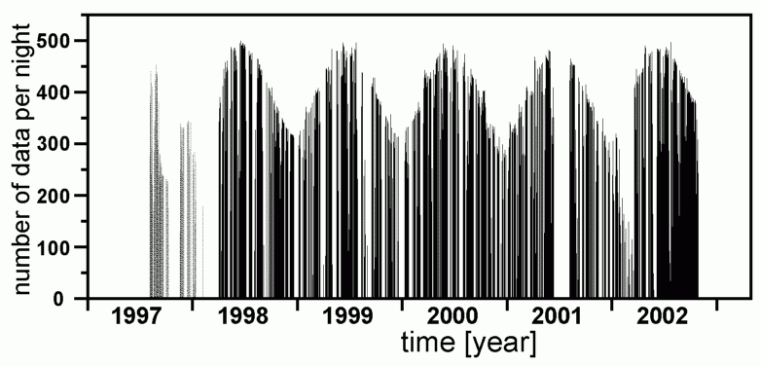
Fig. 1. Number of airglow data per night available at El Leoncito (31.8ºS 69.2ºW), August 1997 - October 2002. Only the data since April 1998 are used to derive solar activity effects. The earlier data are affected by special geophysical conditions (possibly an ENSO effect), and therefore excluded from the analysis.
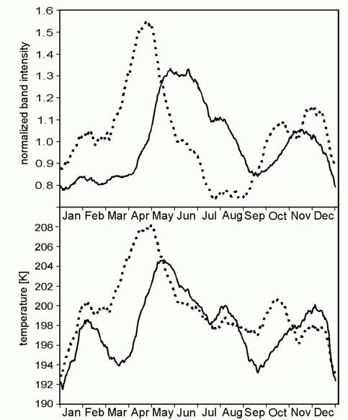
Fig. 2. Seasonal variation for airglow intensities (upper panel) and temperatures (lower panel) at El Leoncito. Solid lines correspond to OH band, dotted lines to O₂ band. Intensities are normalized with respect to their long-term means. The OH temperature curve is shifted up 20 K to save space.

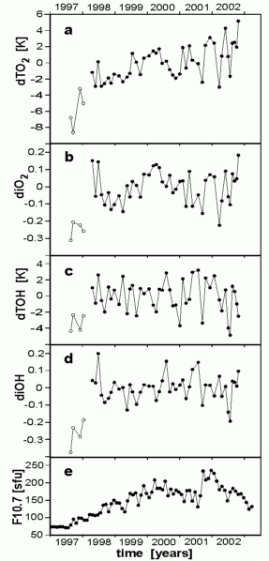
Fig. 3. Block means of deviation from mean seasonal variation for O₂ temperature (a), O₂ intensity (b), OH temperature (c), and OH intensity (d). Monthly means of Penticton observed solar radio flux, F10.7 (panel e) are expressed as solar flux units (sfu).

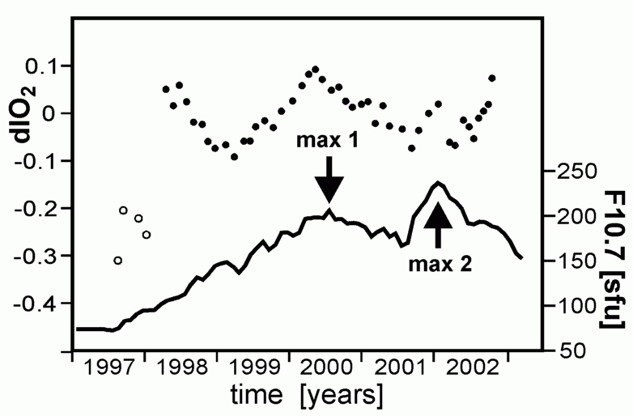
Fig. 4. Same data as Fig. 3 for O₂ intensity (dots) and for F10.7 (solid line), but passed through recursive low-pass filter (1/3 present + 2/3 filtered past; see text for details). Arrows signal the two maxima of solar cycle 23.

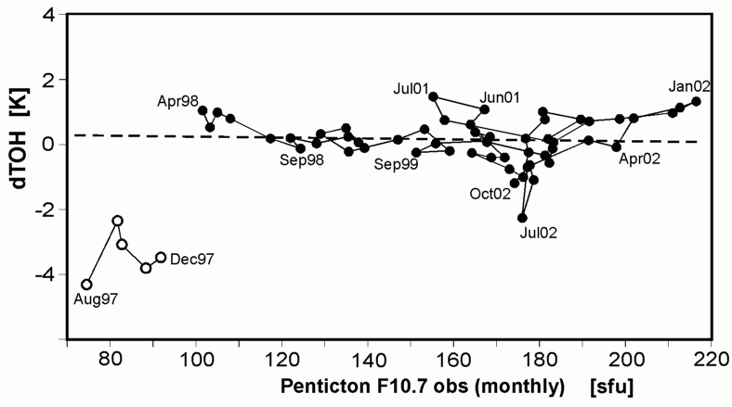
Fig. 5. Behaviour of OH temperature (at 87 km) versus solar radio flux. Data are filtered as in Fig. 4 and temperatures interpolated onto a monthly pattern. Temporal sequence is signalled by line segments and month labels. Linear regression for April 1998-October 2002 is also shown (dashed line).

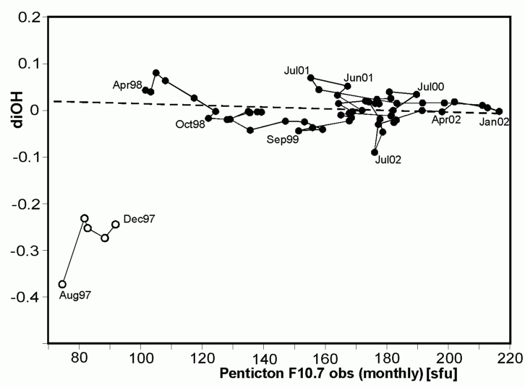
Fig. 6. Same as Fig. 5, but for OH intensity.

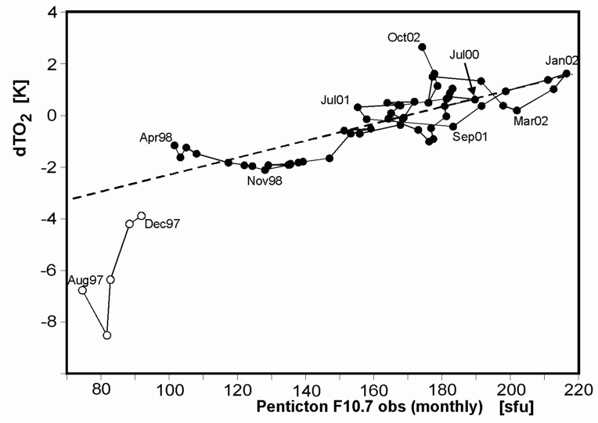
Fig. 7. Same as Fig. 5, but for O₂ temperature (95 km).
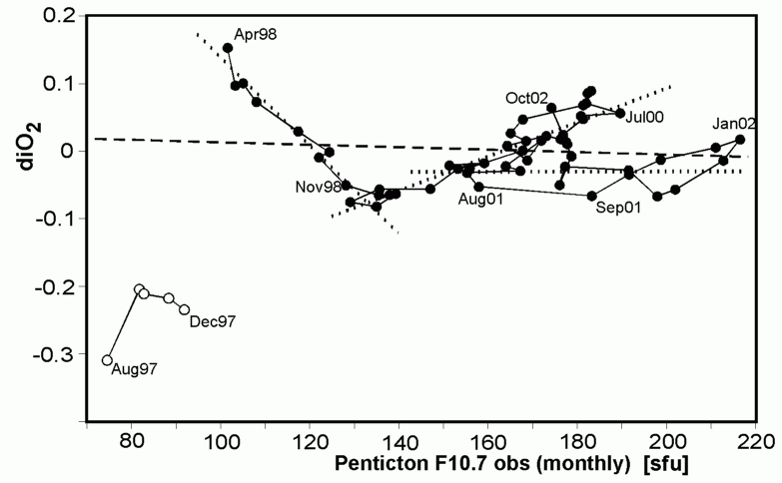

Fig. 8. Same as Fig. 5, but for O₂ intensity. Also regression lines for partial data (April 98 - December 98; December 98 - July 01; and July 01 - October 02) are shown (dotted).

