INSTRUCCIONES PARA LA PREPARACIÓN DE LOS RESUMENES
SEGUNDA LÍNEA
Author One¹, Author Two², and so on
1) Departamento de Física, FCEYN – Universidad de Buenos Aires, Buenos Aires, Argentina
2) Instituto de Astronomía y Física del Espacio, Buenos Aires, Argentina

Este es un jemplo de resumen para la Conferencia DCM, en Buenos Aires. A continuación se presentan las instrucciones para su confección.
1. Abstracts can be written in any language. The length of each abstract is strictly limited to one page. The abstract should be submitted in pdf-format (recommended) or postscript-format through the conference web site. Abstracts which are larger than 30 Mb will not be accepted.
2. Abstracts should be in A4 format (210x297 mm, i.e. 8.268x11.693 inches). All text and figures have to fit within side margins of 2.4 cm and top and bottom margins of 2.4 cm. Use the 11 pt Roman font (Roman is the default LaTex font) or a similar font such as Times New Roman throughout the whole Abstract.
3. The title should be typed in all capital letters and centered. If necessary, use a second line, single-spaced just below the first.
4. Leave two lines before the names of the authors and again before the single-spaced affiliations and addresses.
5. After leaving three lines, the body text is typed in a two-column format with a 0.75 cm column spacing. The text should be single-spaced and the first line of each paragraph should be indented 5 spaces.
6. Remember: the maximum size of each Abstract is 30 Mb.

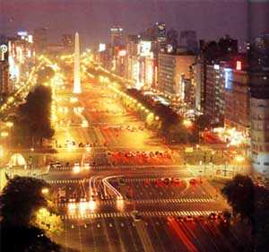
Figure 1: Avenida 9 de Julio y Obelisco

7. References in the text should be indicated using numbers in brackets [1]. The list of references follows the last line of the text with one extra line inserted. Follow the Style of the American Institute of Physics [1], as used in Physical Review.
References
[1] See AIP Style and Notation http://publish.aps.org/STYLE/ (American Institute of Physics, new York, 1993)

